1. Construct a BST from the given preorder traversal result: 15, 4, 1, 12, 10, 20, 30. Explain your approach.
2. Construct a BST from the given postorder traversal result: 2, 6, 4, 9, 13, 11, 7. Explain your approach.
3. Please propose and explain your solutions to the following processes.

(A) Transform a tree into a binary tree

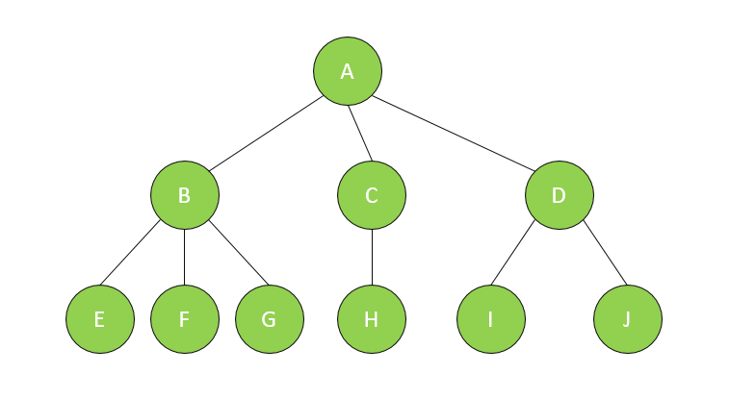

(B) Please propose an algorithm that can transform a forest into binary tree

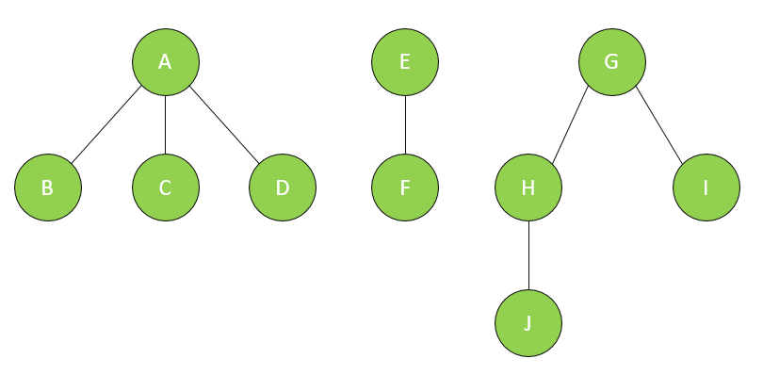

1. Please discuss how to convert a given complete binary search tree into a Min Heap in which every node has its total left subtree node value less than its total right subtree node value.

Input : 4

/ \

2 6

/ \ / \

1 3 5 7

Output : 1

/ \

2 5

/ \ / \

3 4 6 7

The given **BST** is converted into a **Min Heap.**

1. Union is a basic function used in the disjoint set data structure. If you are to construct a set which includes the elements x1, x2, …, xn, starting from an empty set. (i.e. x1, x2, …, xn should be in the same set)
2. Please calculate the total number of operations (make-set and union) needed to establish the set.
3. What is the worst-case time complexity? Please explain your analysis process.
4. According to the exercise 9. Can you think of any other approach to speed up the union function? If yes, please describe how it works and analyze the time complexity of the methodology.
5. Given the disjoint set DS = {0, 1, 2, 5}, {3, 6, 7}, {4}, please show how you may use an “array” to represent this disjoint set. First describe your data structure and then show the result.
6. Please explain how to delete a node for the following binary tree.

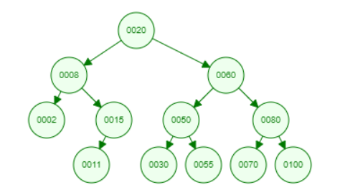

1. Case 1 : Delete 0002 node
2. Case 2 : Delete 0015 node
3. Case 3 : Delete 0050 node

Every tree node has three pointers to its parent, left child, right child. You should explain how to adjust the pointer after a node deletion.